

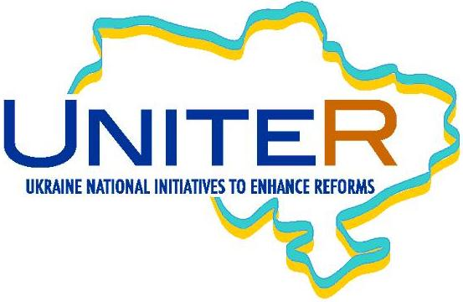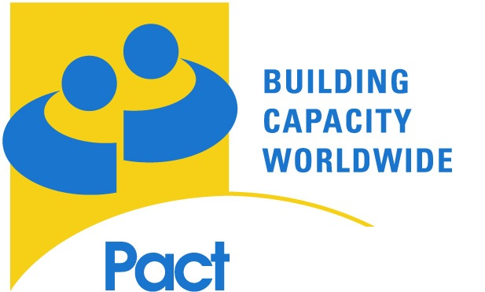

**Use of Information and Data**

**for Enhanced Communication and Advocacy**

Capacity Building Event organized by Think Tank Fund and UNITER/Pact

**March 5-7, 2012 Kyiv**

**Call for Participants**

Deadline: **January 20, 2012**

**Needs assessment**

High quality policy research requires collecting, processing and structuring reliable information. When properly gathered and competently analyzed, this information is a prerequisite for making any evidence-based arguments and impacting concrete policies. Policy researchers collect and process vast amounts of data. However, their outputs often come in the form of lengthy policy papers laden with technical language, textual and static visual knowledge products (texts and charts), which are accessible to only a handful of experts.

While rigorous technical analysis provides a necessary basis for informed expert discussions and sometimes even directly influences policy makers, such an approach is no longer sufficient to reach wider audiences and mobilize coalitions of stakeholders. Technical formulation of policy research products limits the audience of these products to experts and prevents the collaboration on and the reuse of previously processed publicly available data for same or other policy goals. In transitional and emerging democracies information and corresponding policy analysis are not only scarce and/or underutilized, but are also frequently siloed with important context and connections being lost. As such they miss opportunities to create essential knowledge in society and to add the necessary depth and evidence backup to policy discourse.

The recent advancement of new media has further exacerbated the challenges think tanks face. Today think tanks are forced to compete with their knowledge products on the same market of ideas with blogs, news outlets, magazines and electronic media in general. For example, the way how people receive and consume information has changed since the times of books, printed newsletters and offline information sharing in general. We have noticed that while aware of these trends many think tanks in Ukraine have yet to master the art of using the new media and interactive information technology to communicate their results, bring their work to their audiences, and promote it among new, wider target groups by utilizing user-friendly formats and thereby increasing the impact of their ideas. Not only would think tanks benefit from higher visibility and influence of their ideas, but also their products could be of more value for their societies.

The goal of the Ukraine National Initiatives to Enhance Reforms (UNITER/Pact) Project is to strengthen leading pro-reform Ukrainian civil society organizations and assist them in sustaining and consolidating democratic gains. Pact provides support to think tanks and analytical organizations to help them produce high-quality research and channel it to decision-makers and other audiences through creative and targeted communication. Furthermore, Pact is committed to developing capacity of its partners to ensure a profound impact of their research on policy making both in Ukraine and beyond its borders.

The Think Tank Fund aims to complement its financial support to think tanks by targeted capacity building events, especially in relation to improving their communication and advocacy. Within this broader area we particularly see the value in finding new uses of existing data for advocacy, targeting non-traditional stakeholders, developing complementary information sets for a broader policy sphere or challenging commonly accepted facts in a given policy field.

**Call for proposals**

The Open Society Foundations Think Tank Fund and Information Program organized a similar workshop for think tanks from Central and Eastern Europe in March 2011 in Budapest. The event received a very enthusiastic response from many Ukrainian think tanks. At the time we were able to invite only two organizations. Through marketplace mechanisms and direct targeted assistance Pact has in turn offered a variety of capacity building opportunities to its partners and other think tanks including targeted consultations, peer review, engagement of Ukrainian data visualization specialists.

As a follow-up to these events and in order to enhance Ukrainian think tanks’ capacity for understanding and using new techniques for effective presentation, communication and advocacy of their knowledge products, and to increase their ability to seek new tools and forge new alliances, the Think Tank Fund and UNITER/PACT call for participants to attend the capacity building event on “Use of Information and Data for Enhanced Communication and Advocacy.”

**Aims of the event**

The capacity building event will focus on:

1. Providing think tanks with general awareness, knowledge of basic tools and language to formulate and communicate their ideas on how to use data for effective communication and advocacy, and to be able to search and identify tools and partners for their implementation.
2. Providing participants with space to meet their peers, colleagues and prospective cooperation partners who work on similar challenges using data for communication and advocacy.
3. Enabling participants to streamline and clarify the presentation of their particular project ideas in order to be able to raise interest, support and funds for their implementation.
4. Providing participants with an opportunity to talk to experts about challenges they face in implementing their respective projects (on an individual basis).

Participants will discuss tools and concepts related to data collection (scrapers, data-mining, access to information regulations, etc.), processing, presentation and communication (including visualization) for policy research. The workshop will also aim at increasing organizations’ understanding of data processing automation (including text and data extraction) in a way that enables re-use and mash-up as well as interactive data visualization, presentation and crossing between various pillars and sectors.

The event will begin with general sessions on a good communication and advocacy strategy and a growing influence of data visualization tools in public policy analysis and presentation. Representatives from Western and Central European think tanks will join the seminar to share their experience in these areas. Experts from the Jefferson Institute[1] will continue the workshop with hands-on training on specific techniques and tools, consulting and networking sessions in small groups.

**Application process**

**Eligibility: Ukrainian think tanks only**

The term “think tank” defies an exact definition, as organizations in different parts of the world that appear under the term vary considerably in size, legal form, policy domain, organizational structure, standards of inquiry, and political significance. The UNDP defines think tanks as “organizations engaged on a regular basis in research and advocacy on any matter related to public policy”.[2] In order to assess applications from organizations in Ukraine that claim to be think tanks we would use the following definition: “Think tanks are independent (and usually private, in Ukraine mainly registered as NGOs) policy research institutes containing people involved in studying a particular policy area or a broad range of policy issues, actively seeking to educate or advise policy makers and the public through a number of channels”.[3] Only in **exceptional** cases we will consider advocacy NGOs with well developed in-house research capacity for participation in this event.

An applying think tank must submit names of **two staff members** with its application. One individual should represent an organization’s senior leadership (e.g. director or deputy director), and the other should be at the level of a senior/mid-level policy analyst. If an organization is selected, the senior leadership will be asked to attend two general sessions on March 5 (see the agenda). A senior representative can choose to attend other sessions if time permits. A policy analyst will be required to attend all of the sessions. The organizers will provide full board and lodging for the entire duration of the seminar.

Please note that the language of the training will be English. We will provide simultaneous translation in English and Ukrainian only for two general sessions on March 5, 2012. No translation will be provided for the rest of the workshop. Therefore, please make sure that your nominees are fluent in English and are able to use English as their working language.

The application should include a preliminary project idea and demonstrate the motivation and willingness of an organization to engage in and develop this new communication and advocacy skill. In order to apply, please fill out the online application form. Please be sure that your application includes a description of the project. Successful applications will demonstrate a project that an organization intends to implement within the next few months. After being selected you will be invited to take part in the preliminary online event on February 27-March 2, 2012.

Deadline for applications: **January 20, 2012**

Selection notification: **February 10, 2012**

**Please see attached:**

- Draft program

- Link to the application form

**Draft Agenda**

March 5, 2012

*Morning sessions: will be conducted in English and Ukrainian, translation will be provided. Panels will include representatives of Western and Central European think tanks.*

- Welcome and Introductions

- Why is a good communication strategy important?

- Data visualization: who needs it and why?

*Afternoon sessions: will be in English only, no translation will be provided. Sessions will be conducted by experts from the Jefferson Institute.*

- Open and closed data in context and why it matters

- Open government data in your country

March 6, 2012

Topics to be covered (English only): data discovery and reuse; information visualization; evidence-based advocacy; tech project management; how to create/foster user's communities (working with journalists/super-users); dangers of crowdsourcing; government spending tracked ; online legislative accountability; geospatial tools & policy data; making sense of spending data.

March 7, 2012

*Morning sessions (English only)*

- Individual consultations between the think tanks and the experts. This time should be used for the think tanks to sit down with the experts and ask questions based on what they've heard or how they see their initiatives developing into something specific in the future.

- Conclusions/evaluations

*Afternoon: departures*

Link to the application form: <https://docs.google.com/spreadsheet/viewform?hl=en_US&formkey=dEN3ZmxvUlJlb3hadG9LdVJIejdTWFE6MA#gid=0>

1. Please visit the Institute’s website at <http://www.jeffersoninst.org/>
2. Source: UNDP (United Nations Development Program). 2003. *Thinking the Unthinkable*. Bratislava: UNDP Regional Bureau for Europe and the Commonwealth of Independent States.
3. Source: Stone, Diane. 2000. Think-tank Transnationalisation and Non-profit Analysis, Advice and Advocacy, Vol.14, No.2, Jan 2000: